DEVELOPMENT OF A SENSITIVITY ANALYSIS APPLICATION FOR AN EVENT-BASED HEC‒HMS RAINFALL-RUNOFF MODEL
B2. Sensitivity analysis – describing the application

We intend our application to meet the needs of a specialist in hydrology regarding the sensitivity of a model to different parameters before optimizing it. This precursory analysis helps at finding better initial values for the parameters chosen for calibration. The application is made for the case of Siron river basin, but with minor changes to the code it could also be used for other cases). We will call our application HEC-HMSens and we gladly present it now.
We chose to develop our application using Java programming language due to the fact that in the assignment description it was mentioned that JAVA libraries can be included in the Jython scripts edited in HEC-DSS’ Script Editor. We also used JAVA programming language for the ease that the Object Oriented Programming combined with the Graphical Design provides to any developer.
We tried to make the application simple to use, performant in terms of computing time, optimized (as much as complexity is concerned) and USER-FRIENDLY (always communicating with each other in this matter and being assisted by our colleague from the Hydrology area of activity).
As a brief description of the Application's functionality we would first like to mention the fact that we tried as much as possible to make this Application as complete as possible in terms of automation: we used scripts and batch files runnable on Windows OS that can automate the process of launching HEC-HMS, running the Simulation for the desired model, making file copies required for reading some result, overwriting etc.
The App's Interface looks as shown in Figure 1.

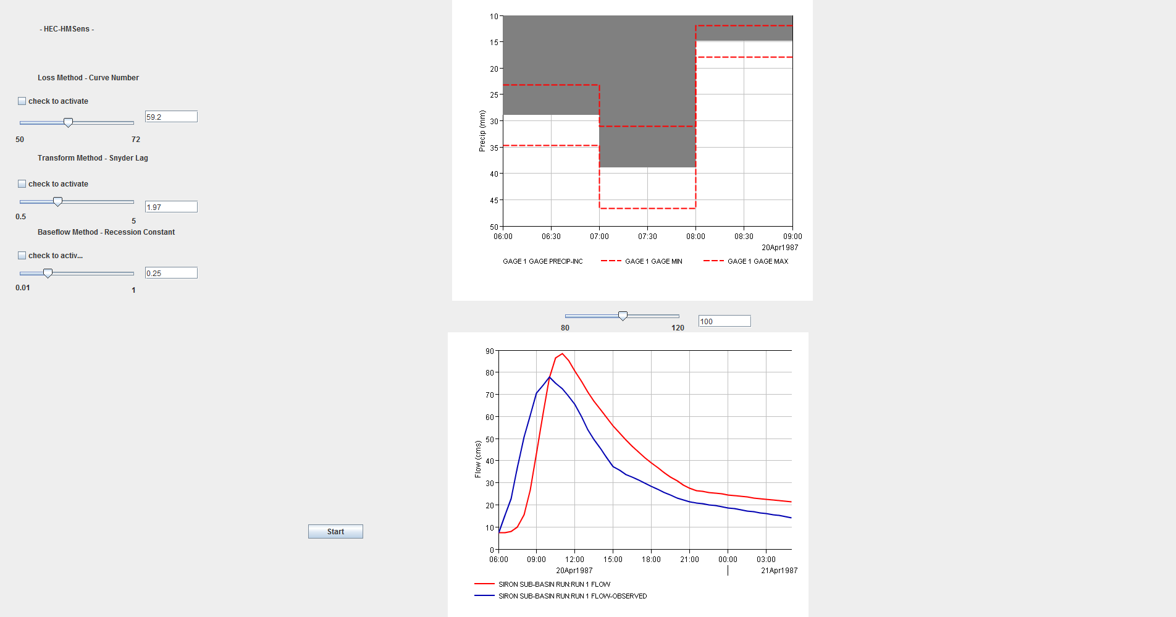
Fig .1
The three sliders of the left are used to vary the parameters for the SSC Curve Number, Snyder Lag Number and Recession Constant (Fig. 2)
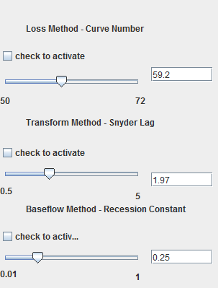
Fig. 2

On the right side we can see another slider that can give as an input for the App the new percentage of the Precipitation. On the right side we can also see the placement of two graphics. On the top side is the Hyetograph (Fig. 3a) plotted and on the bottom we have the Hydrograph(Fig. 3b).

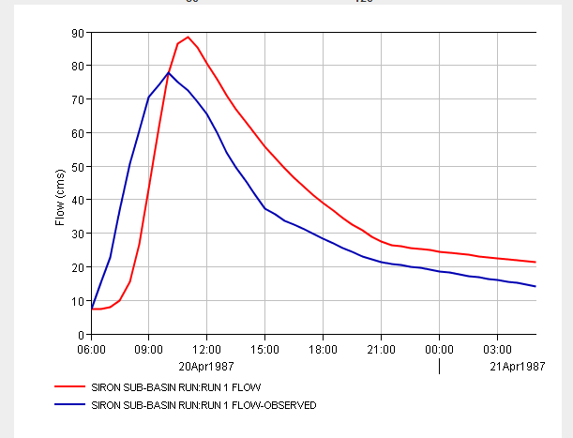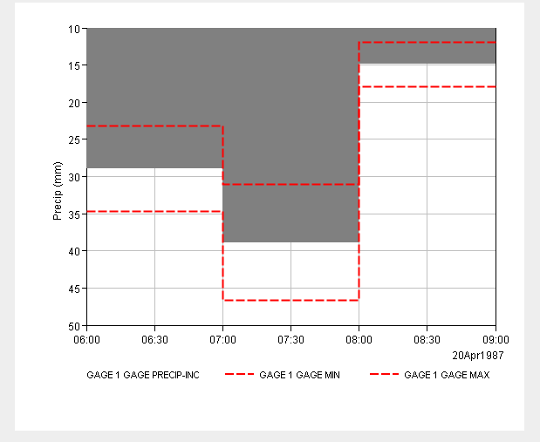
Fig. 3a Fig. 3b

The button START gets our application running.
Without going too much into detail our application works as follows:
1. On running, the application launches the Interface Window where the User can set the parameter(s) for which the sensitivity analysis is needed. By default, the values of the parameters are set to the value used during the first assignment (building the model).
2. The START button triggers the beginning of the background execution as follows (shortly presented):
- The program overwrites the values of the optimized parameters in the Siron basin file.
- Then it writes the new value of Precipitation through a script that updates the values and writes them in Run_1.dss file (if there is a new value; otherwise it skips this step q.v. optimization).
- At this point a script launches HEC-HMS and Computes Run1 Simulation
- When the computation is finished, two Jython scripts create two plots: the hyetograph and the hydrograph (with the simulated and observed discharge overlayed), by opening certain .dss files which contain precipitation data. The plots are then exported in PNG format.
3. The PNG files are displayed on the Interface and the user can see the new results and analyze the impact/effect of the parameter value change on the hydrological processes.

