Part B1
Our application is a two part solution, because we thought that is much more useful to solve the problem using this approach:
- Desktop based
  - This implements the following specifications:
    - It allows modification of each parameter individually or collectively, and it plots the results in real time.
    - It allows for sliding the values of one parameter and updating the plot in real time.
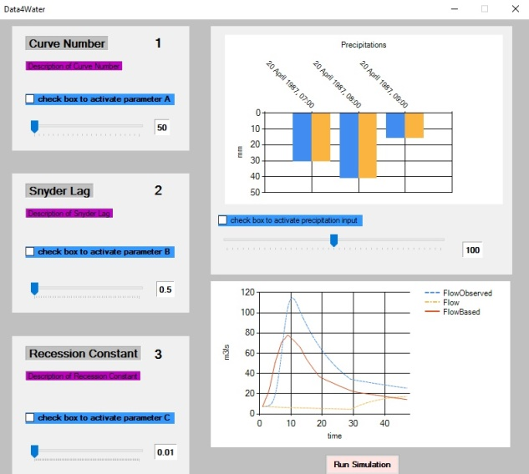
- Web based
  - This implements the same specifications as the desktop based version except for the feature of allowing multiple parameters to be collectively modified.
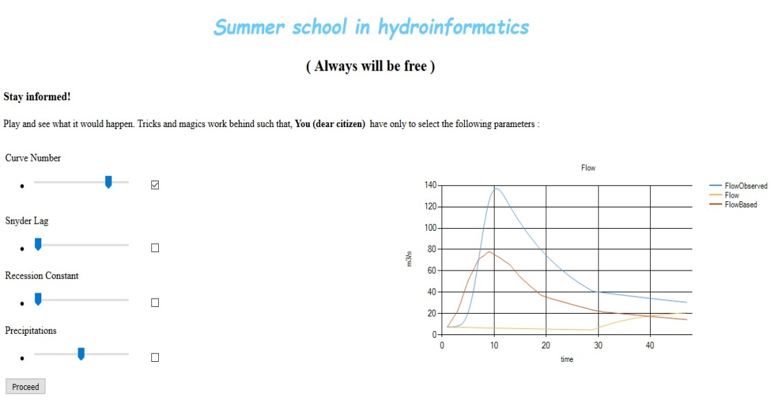
We developed our solution such that it is very easy for the user to make use of it.
How to use the application (desktop based):
Strategy 1:
- Change the parameters you want.
- Press Run Simulation. The results are calculated thus the plot would be updated.
Strategy 2:
- Thick the box for the parameter you want to analyze the effect. The results would be plotted in real time.
How to use the application (web based):
- Thick the box for the parameter you want to see the influence on the model
- Push Proceed button. The plot would be updated with new results.

How the application works:
The plan we undertook has the following steps:
Step1. Edit, modify and save HEC-HMS input files
Step2 .Run HEC-HMS without the GUI
Step3. Extract HEC-HMS outputs from HEC-DSS file for further use
Step4. Pre-compute data such that for incremental values in Curve Number, Snyder Lag, Recession Constant and Precipitation, charts are updated in real time
Step5. Run the model with a collection of parameters modified by the user such that data are plotted

Future directions:
- Implementation of a new version of web based application with the following features:
  - Sliders, when changed would trigger an update function for the chart and pre-computed data are loaded for the user.
  - Login interface.
  - Access to Big Data
- Implementation of an android application is considered, such that:
  - The results of the models run on institute`s servers are sent to clients.
  - Graphs and different visualizations tools (plots, statistics, geographic maps, etc.) are used to make the citizen realize the real impact of parameters of interests upon the environment.

