Newsletter  February 2018 | Issue 2 |  |  |  | 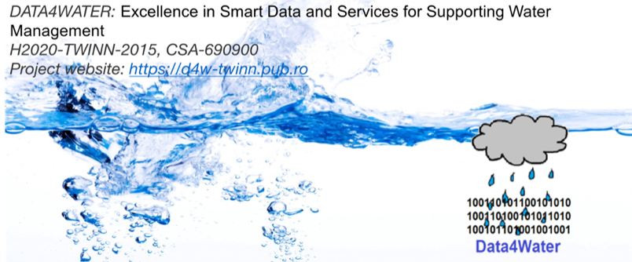
Project Aims and Activities  Data4Water is a H2020 CSA project having as main activities the organization of workshops, summer schools, exchange and training of researchers, develop a road-map for the UPB (the host institution of the project) in the area of IT for water management, development of a knowledge transfer and remote training system, and inclusion of UPB team in an operational research network. The scientific strategy of the UPB team will be oriented towards inter/trans-disciplinary and practical applicability, valorization and impact in water management, which also fits to the Smart Specialization Strategy of Romania. The main expected impact is the increase of publications number with high visibility, and the creation of an active network with relevant stakeholders.  Call: H2020-TWINN-2015  Topic: H2020-TWINN-2015  Type of action: CSA  Project number: 690900  Proposal acronym: DATA4WATER  Project website: http://data4water.eu  Networking and Knowledge E-Environment  http://data4water.pub.ro |  | OUR MAIN Activities
- Research QA Handbook. The Research Quality Assurance Handbook provides a guide of best practices for the staff involved in teaching and research at department level, and for the faculty’s Quality evaluation and Assurance Commissions. The requirements, quality metrics and quality assurance models adopted in the Research Quality Assurance System (RQAS) are compliant with the H2020 research programs and with the European level KPIs. The Research Quality Assurance Handbook includes the background of QA, the experience of European partners in the D4W project, the Romanian QA of the research and education, the improvements proposed for QA in the research group, and the RQAS for Smart Data & Services research group. For more information please contact us at: d4w@cs.pub.ro.
- Development of a network of excellence and partnership through a Meetup networking event in Berlin (23. November 2017, 17:00 - 20:00, Fraunhofer FOKUS).
The following topics and demos were presented:
  - Berlin Center for Digital Transformation (https://www.digitale-vernetzung.org/en/dv/about/berlin_center) (Petra Steffens)
  - IoT Lab Demo (https://www.digitale-vernetzung.org/en/dv/transfer_centers/iot): enyCLS (Peter Hasse), Real-time Data Hub (Fabian Kirstein), Semantic Annotation (Raed Younes), Data Analytics Center Predictive Maintenance (Alexandru Todor)
  - IT4Energy Lab (Florin Popescu)
  - Social Networking "Future Directions of Smart Data for Water Management"
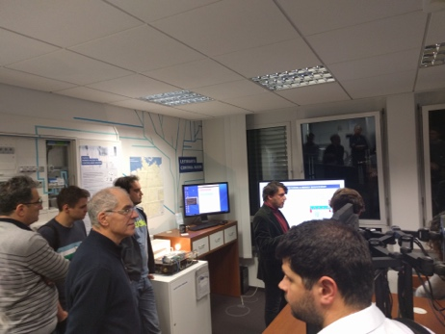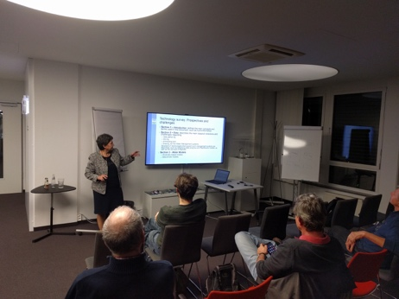
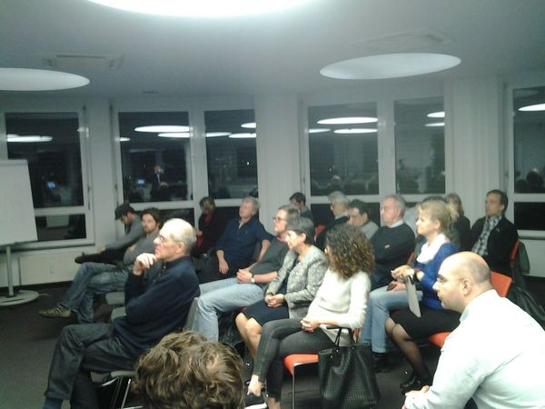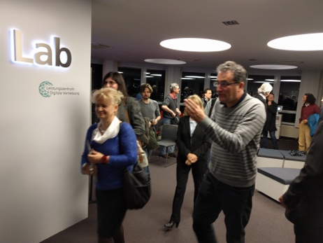
For more information please join the Data4Water NoE at: https://www.linkedin.com/groups/13502078/
Data4Water Project  Partners | 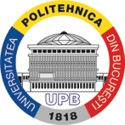 |  |  |  | 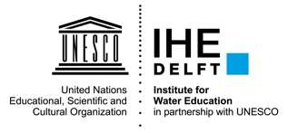
OUR MAIN ACTIVITIES
- The second Summer School took place from 12th June to 23th June 2017. The topic was ‘Using Data Science for Urban Water Management’. The second Summer School was organized by project partners from University of Milano-Bicocca and University Politehnica of Bucharest.
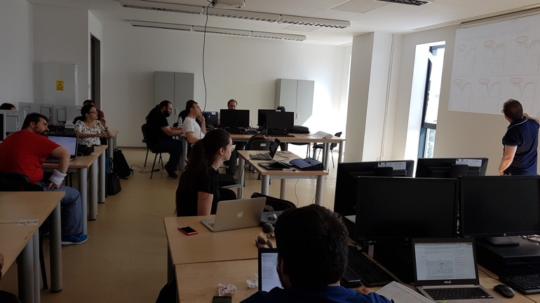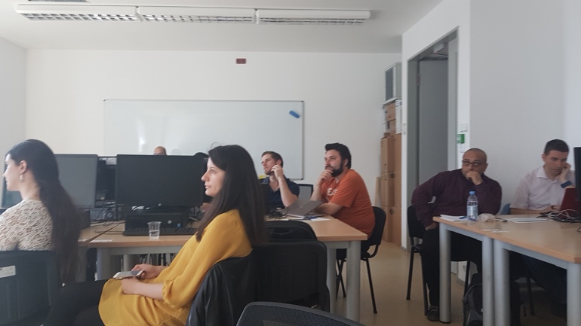
- The 4th training session was organized in Bucharest by IHE Delft Institute for Water Education and University Politehnica of Bucharest. This training session has the following topics: Optimization and dynamic programming for water problems and took place from the 18th of October to the 20th of October 2017. The detailed syllabus of the training courses was as follows:
  - Introduction to optimization, Definitions (single objective, multiple objective, constrained-unconstrained, etc.), Traditional methods (Calculation by hand, linear programming, dynamic programming), Optimization for water related problems, Examples.
  - Model based optimization, Water case studies, Genetic algorithms.
  - Calibration in hydrological modelling.
- PhD students involved in research in smart data for water management domain
Loredana-Marsilia Groza
Advanced Techniques for Big Data Processing in Smart Cities Platforms
Contact: groza.lore@gmail.com
Claudia Ifrim
Data Reduction Analytics on Wireless Network Sensors
Contact: ifrim.claudia@gmail.com
George-Valentin Iordache
SLAs4Water: Service Level Agreement Characteristics of Monitoring Wireless Sensor Networks for Water Resource Management
Contact: george.iordache@cs.pub.ro
Dan Huru
Scalable data processing in the Internet of Things
Contact: danut.huru@gmail.com

Research issues related to ICT for Water Management identified during networking sessions
Optimization of the water supply management ⋅ Improvement of the river monitoring ⋅ Public access to the hydrological data ⋅ Data infrastructure ⋅ Water Data Modelling, structure of the collected data ⋅ Algorithm for analytics to build smart decision systems ⋅ Data cleaning and aggregation ⋅ Ontologies on Smart Data for Water Management ⋅ Computing intensive algorithms ⋅ Standards and protocols for water resource management ⋅ Interoperability between different systems ⋅ E-Services for Water Management ⋅ Appropriate Sensors, Networks, Software ⋅ Big amount of data (smart analysis, smart insight, security) ⋅ Automatic data versus manual measurements ⋅ Satellite data ⋅ Data collections between different sites ⋅ Access to date provided by different companies ⋅ Internet of everything ⋅ Telemetry use cases
PUBLICATIONS
- Vlad-Cosmin Ozunu, Cezar-Costin Pirvu , Catalin Leordeanu, Valentin Cristea; Distributed Platform for the Analysis of Cryptographic Algorithms, Publication in Conference proceedings/Workshop, 2016 10th International Conference on Complex, Intelligent, and Software Intensive Systems (CISIS), pg. 296-301, Electronic ISBN: 978-1-5090-0987-9; CD-ROM ISBN: 978-1-5090-0986-2; Print on Demand(PoD) ISBN: 978-1-5090-0988-6; IEEE, 2016, http://ieeexplore.ieee.org/document/7791898
- Valentina-Camelia Bojan, Ionut-Gabriel Raducu, Florin Pop, Mariana Mocanu, Valentin Cristea, Architecture design of pattern detection system for Smart cities datasets, Publication in Conference proceedings/Workshop, 2016 IEEE 12th International conference on Intelligent Computer Communication and Processing (ICCP), Electronic ISBN: 978-1-5090-3899-2; USB ISBN: 978-1-5090-3898-5; Print on Demand(PoD) ISBN: 978-1-5090-3900-5; IEEE, 2016, http://ieeexplore.ieee.org/document/7737180
- Mariana Mocanu, Valentin Cristea, Ciprian Dobre, Florin Pop, Smart Data for ICT-based Water Management, Publication in Conference proceedings/Workshop, 2016 16th Biannual Conference ERB – Hydrological behavior in small basins under changing conditions, 2016
- Ciolofan, Sorin N.; Pop, Florin; Mocanu, Mariana; Cristea Valentin; Rapid Parallel Detection of Distance based Outliers in Time Series using MapReduce, Article in Journal, CONTROL ENGINEERING AND APPLIED INFORMATICS journal, pg. 6371, ISSN: 1454-8658, Volume: 18, Issue: 3, 2016, http://www.ceai.srait.ro/index.php?journal=ceai&page=article&op=view&path%5B%5D=3762
- Ciprian Lupu, Doinita Chirita, Serban Iftimea, Roxana Miclaus; Consideration on leak/fault detection system in mass transfer networks, Publication in Conference proceedings/Workshop, 2016 20th International Conference on System Theory, Control and Computing (ICSTCC), 2016 EENVIRO – Sustainable Solutions for Energy and Environment, Electronic ISBN: 978-1-5090-2720-0; DVD ISBN: 978-1-5090-2719-4; Print on Demand(PoD) ISBN: 978-1-5090-2721-7; IEEE, 2016, http://ieeexplore.ieee.org/document/7790754
- Anca Daniela Ionita, Mariana Mocanu; Architectural Framework for Hazard Warning Systems, Publication in Conference proceedings/Workshop, CENTERIS 2016 – Conference on Enterprise Information Systems, ISBN: 978-989-97433-7-3, 2016, http://centeris.scika.org
- Catalin Negru, Florin Pop, Mariana Mocanu, Valentin Cristea, Anca Hangan, Lucia Vacariu; Cost-aware Cloud Storage Service Allocation for Distributed Data Gathering, Publication in Conference proceedings/Workshop, 2016 IEEE International Conference on Automation, Quality and Testing, Robotics (AQTR), Electronic ISBN: 978-1-4673-8692-0; USB ISBN: 978-1-4673-8691-3; IEEE, 2016, http://ieeexplore.ieee.org/document/7501280
- Marian Muste, Mariana Mocanu; Interjurisdictional Collaboration in Water Resource Management, Publication in Conference proceedings/Workshop, 2016 IEEE International Conference on Automation, Quality and Testing, Robotics (AQTR), Electronic ISBN: 978-1-4673-8692-0; USB ISBN: 978-1-4673-8691-3, IEEE, 2016, http://ieeexplore.ieee.org/document/7501393
- Anca Daniela Ionita, Mariana Mocanu; Modeling Framework for Hazard Management Applied to Water Pollution and Radiation Dispersion, Publication in Conference proceedings/Workshop, 2016 IEEE 12th International Conference on Intelligent Computer Communication and Processing (ICCP), Electronic ISBN: 978-1-5090-3899-2; USB ISBN: 978-1-5090-3898-5; Print on Demand(PoD) ISBN: 978-1-5090-3900-5, IEEE, 2016, http://ieeexplore.ieee.org/document/7737136
- Dan Popescu , Loretta Ichim and Florin Stoican; Unmanned Aerial Vehicle Systems for Remote Estimation of Flooded Areas Based on Complex Image Processing, Article in Journal, Sensors 2017, 17(3), 446; MDPI, ISSN: 1424 – 8220, accepted for publication in 2017, DOI: 10.3390/s17030446, www.mdpi.com/journal/sensors
- Costin Gabriel Chiru, Mariana Ionela Mocanu, Monica Dragoicea, Anca Daniela Ionita; Digital Services Development Using Statistics Tools to Emphasize Pollution Phenomena, Publication in Conference proceedings/Workshop, 8th International Conference, IESS 2017, Springer, ISBN 978-3-319-56924-6, 2016, http://www.springer.com/it/book/9783319569246
- George Iordache, Adrian Paschke, Mariana Mocanu and Catalin Negru: Service Level Agreement Characteristics of Monitoring Wireless Sensor Networks for Water Resource Management (SLAs4Water), in SIC Journal (Studies in Informatics and Control), Special Issue Advanced Services in Heterogeneous Distributed Systems, 11/2017

DISSEMINATION AND NETWORKING ACTIVITIES
Big Data Value Forum 2017. The EBDVF 2017 (http://www.european-big-data-value-forum.eu/) on 12-14 Nov. 2018 in Paris was a key European event for industry professionals, business developers, researchers, and policy makers to discuss the challenges and opportunities of the European data economy and data-driven innovation in Europe. Dr. Yuri Glickman and Prof. Dr. Paschke attended the EBDVF 2017 event and disseminated the Data4Water project.
STI2 Semantic Summit 2017. Prof. Dr. Paschke was invited as an expert to STI2 Semantic Summit (https://www.sti2.org/events/2017-sti2-semantic-summit) on September 4-5 in Heraklion, Greece. The STI Semantic Summit is a bi-annual strategic event where key player within the Semantic Web and Linked Data community can come together to discuss medium and long-term research issues. Prof. Paschke presented about the Data4Water project and introduced the discussion topic for the working group identifying key scientific challenges: „Semantic data-driven e-services in water resource management”.
Wasser Berlin International. Prof. Dr. Paschke participated at the Wasser Berlin International 2017 (http://www.wasser-berlin.de/en/) fair in Berlin. He attended the „Wastewater – The Untapped Resource” symposium on 30. March 2017, which was organized by Blue Planet Berlin Water Dialogues, and the „Water Management 4.0” Workshop organized by the IWA YWP Chapter Österreich und Deutschland.
Fraunhofer Big Data Alliance Meeting. Prof. Dr. Paschke participated in the Fraunhofer Big Data Alliance Meeting on 10.5.2017 at the Fraunhofer-Institutszentrum Schloss Birlinghoven in Germany and presented the Data4Water project.
Members of the Data4Water consortium disseminated the project at international conference and workshops such as the OnTheMove Conference (OTM2017), International Conference on Rules and Reasoning (RuleML+RR2017), 21st International Conference on Control Systems and Computer Science (CSCS21).

Upcoming work, events and dates
- Info Day - Data4Water 2018 Research in Water Management: this information and networking event shares your knowledge and open issues with all participants and find new collaborations through a network of excellence in this new exciting domain of ICT for water management, in Berlin, Fraunhofer FOKUS, on 15 February 2018. For more information, please access the link: https://www.fokus.fraunhofer.de/en/data4water_2018.
- 3rd Summer School - “Scientific Literature Analysis for Water Management” - Date: June 18-20, 2018 tutorial; June 20 - July 13th Summer School + final presentation on 23.07.2018. Contact us at: d4w@cs.pub.ro.
- 12th Symposium and Summer School On Service-Oriented Computing (SummerSoc 2018), June 24 – June 29, 2018 in Crete, Greece, a well-established summer school and symposium focusing on service-oriented computing - http://www.summersoc.eu (Paper submission deadline: March 16th, 2018).
- Scientific Challenges & Business Opportunities in Water Management (SciBOWater 2018). The workshop intends to address the topics relevant for the BIS conference, but with a particular focus on water management, and will take place in Berlin, Fraunhofer FOKUS, 18-20 July 2018- http://bis.ue.poznan.pl/bis2018/workshops/scibowater (April 15, 2018 – submission deadline for papers).
- DC @ BIS 2018: The Doctoral Consortium will be held in conjunction with BIS 2018 conference and provides doctoral students with the chance to present and obtain comment on their research, to hear about the work of their peers at other universities, and to interact today’s leading researchers from different universities and countries - http://bis.ue.poznan.pl/bis2018/doctoral-consortium (Submission deadline: May 8, 2018).
- 21th IEEE International Conference on Computational Science and Engineering - http://cse2018.hpc.pub.ro
- 16th IEEE/IFIP International Conference on Embedded and Ubiquitous Computing - http://euc2018.hpc.pub.ro
- 13th International Hydroinformatics conference (HIC 2018, www.hic2018.org), 1-6 July, 2018, Palermo, Italy.

Data4Water: Network of Excellence and Partnership in Smart Data for Water Management.
Join us on LinkedIn - https://www.linkedin.com/groups/13502078

Stay in touch with our project updates on http://data4water.eu | 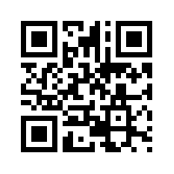 | 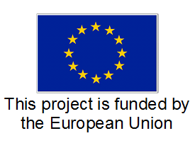 | 