Newsletter  June 2017 | Issue 1 |  |  |  | 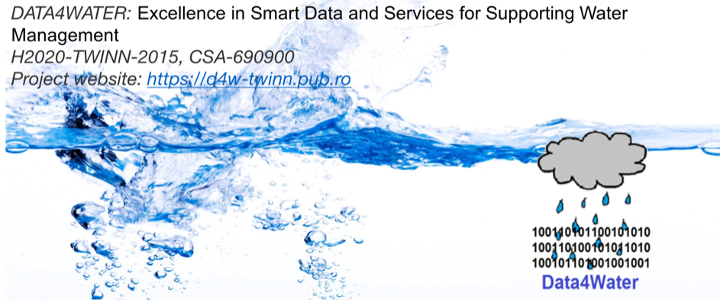
Project Objective  The objective is to enhance the S&T abilities in the field of smart, data driven e-services in water management, with focus on the widening organization. The complexity of research related to water management is extremely high and requires deep expertise in several ICT-related research domains. The dynamics of water and the role of humans in the water cycle are not well understood largely because environmental and socio-economic analyses are still performed separately.  The specific objectives are: Enhance the science and technology capacity of the participating institutions; Raise staff’s research profile as well as the one of the institutions involved; Contribute to the Smart Specialisation Strategy; Contribute to the development of a new, interdisciplinary research domain.  Call: H2020-TWINN-2015  Topic: H2020-TWINN-2015  Type of action: CSA  Project number: 690900  Proposal acronym: DATA4WATER  Project website: http://data4water.eu |  | aS we gather together…
Data4Water: Network of Excellence and Partnership in Smart Data for Water Management. Join us on LinkedIn!

https://www.linkedin.com/groups/13502078

Training Sessions
- Hydroinformatics approaches for river basin related problems – UNESCO-IHE (21-23 June 2016).
- Open Government Data, Basics of Linked Data and Semantic Web Technologies, and Semantic Rule Technologies – FOKUS (9-11 November 2016)
- Using Data Science for Urban Water Management – University of Milano-Bicocca (31 May – 2 June 2017)

Summer School 2016 – Intelligent Metering and Big Data in Hydroinformatics (June, UPB, Romania)
Summer School 2016 – Using Data Science for Urban Water Management (June, UPB, Romania)
Read more… on our Knowledge-lake.
Networking and Knowledge E-Environment, "Knowledge-lake"

http://data4water.pub.ro

Networking event
January 21th, 2017, Bucharest, Romania

“ICT for Water Management: Enabling Smart Data Information and networking event for practitioners and researchers”. This event provided an interactive and professional forum for exchanging practical experience and sharing novel research ideas and ground-breaking results. The sessions targeted modern water supply and integrated water resource management with representative from public administrations, industry and academia.
Highlights:
- Presentation of existing water management systems from Romanian industries: ApaNova, BEIA, Oracle;
- New research issues presented in hydro-informatics (GeoEcoMar, INHGA, UNESCO-IHE, UTCB);
- Conclusion of the Panel Session: UPB team has a well-establish position in smart data research area to conduct a pilot on water management.
Read more… on Knowledge-lake.

Develop the framework for scientific strategy enforcement
- Technology survey for smart data and services for water management, was elaborated by the UPB team in collaboration with the partner institutions from this project.
- Roadmap of the UPB research team in project domain, presents a Roadmap for the research group, as a general, strategic plan for enhancing the research activities and results in the field of smart data for water management.
Read more… on our Knowledge-lake.

Data4Water Project  Partners | 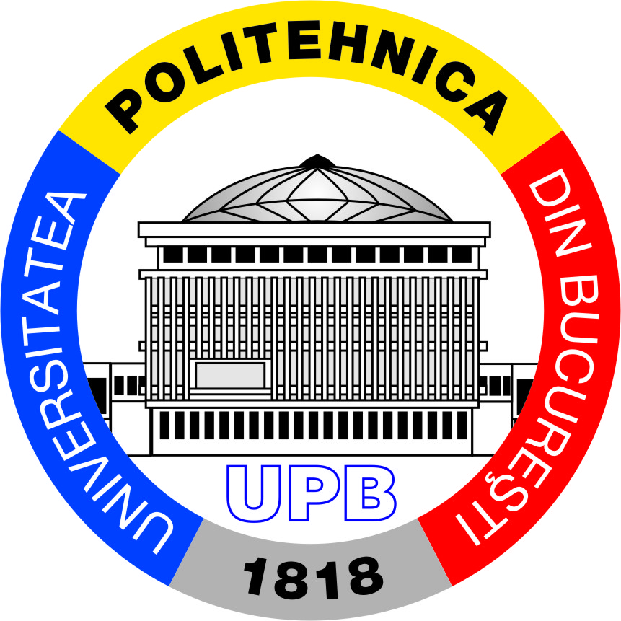 |  |  | 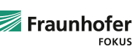 |  | 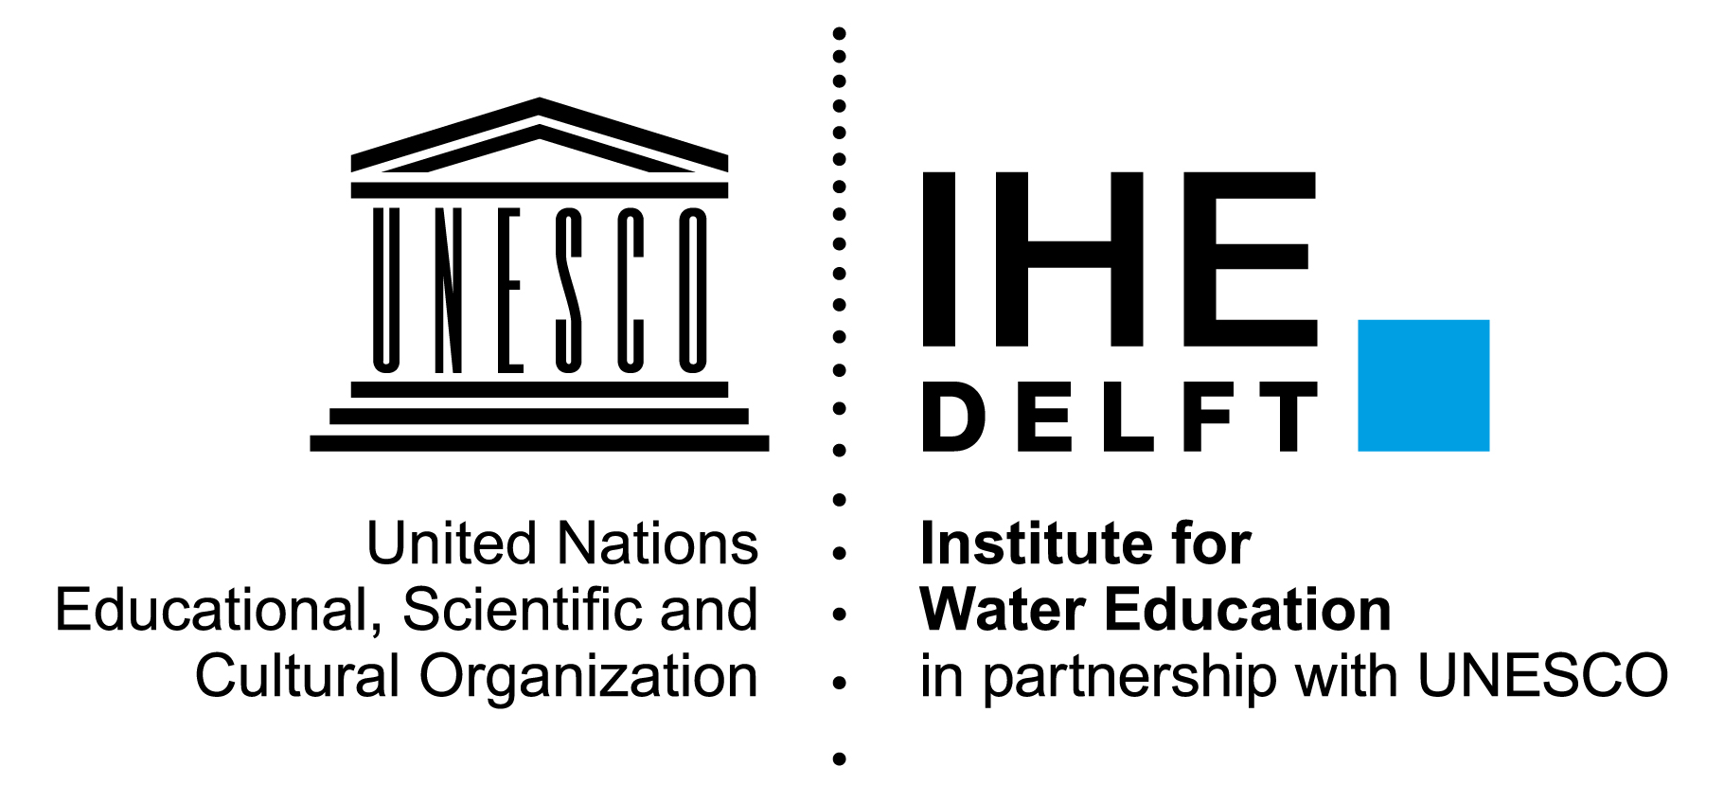
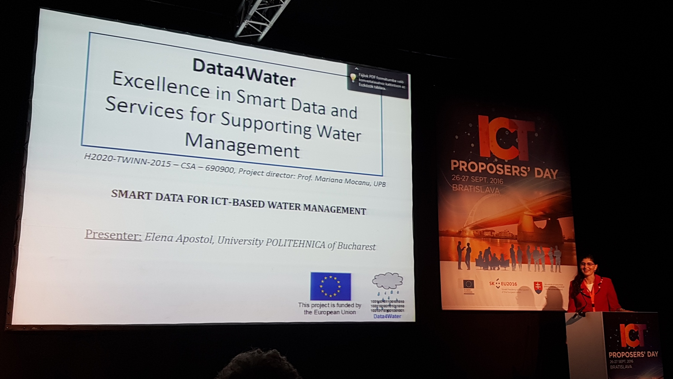
Scientific Events and Dissemination Read more… on our Knowledge-lake.
- Water Week organized by the SIWI in Stockholm [link]
- Wasser Berlin International 2017 [link]
- IEEE International Conference on Advanced Information Networking and Applications [link]
- Fraunhofer Big Data Alliance – Energy and Environment 2016 and 2017 [link]
- International Conference on Automation, Quality and Testing, Robotics [link]
- Workshop on Autonomic Distributed Systems [link]
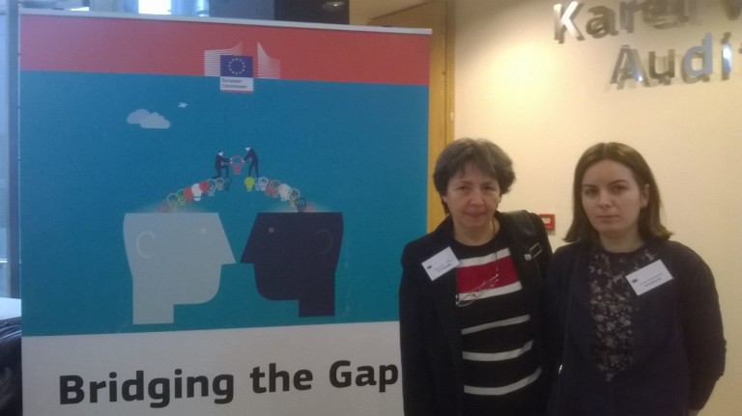
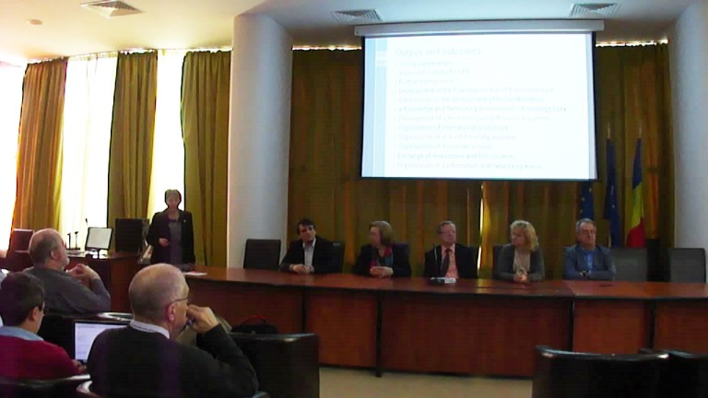
- International Conference on Complex, Intelligent, and Software Intensive Systems [link]
- European Academy - Practical Seminar [link]
- ICT Proposers' Day 2016 [link]
- The Conference on Sustainable Solutions for Energy and Environment [link]
- The 8th International Conference on Exploring Service Science [link]
- The 21st Int. Conference on Control Systems and Computer Science [link]
- The Third International Workshop on Cyberinfrastructures for Natural Resources Management [link]
- Three internal workshops and staff exchanges organized by project partners: UPB, Fraunhofer FOKUS, UNESCO-IHE, UNIMIB.
Upcoming work, events and dates
- Research QA Handbook. Based on the best practices, a Research Quality Assurance System will be defined and implemented. A metric for quality in research, focused on criteria used on European level KPI, as well as methods to collect, to store and to analyse information regarding research activities and results, will be set up. A RQA Handbook will be elaborated in order to implement and institutionalize the RQAS.
- Research Quality Report. The quality assurance process enables the selection of tools and methods that will enhance the research group ability to meet the quality and research- performance objectives. During the project, quality evaluation will be performed and a Research Quality analysis will be performed, and the results will be published in the RQA-report.
- New staff exchanges between project partners: UPB, Fraunhofer KOKUS, UNESCO-IHE, UNIMIB.
- New collaborations established to create consortiums for the next national and international research projects calls.
- COST Action Proposal on data infrastructure for water resources management: September 2017. Please join this initiative by writing a Letter of interest at d4w@cs.pub.ro.
- LinkedIn group, expand the network of excellence. Please join us on LinkedIn: https://www.linkedin.com/groups/135020.
- Next networking day will be a Focus Group event, oriented on H2020 project proposals. Join us for this event on 20th October 2017, Bucharest, Romania.
- A summer school will be organized in 2018. It will include a competition for developing the best solution to a problem related to the management of a critical situation in the use of water resources.
- PhD Students visits at project partners.
Read more… on our Knowledge-lake.
Stay in touch with our project updates on http://data4water.eu |  |  |  |  | 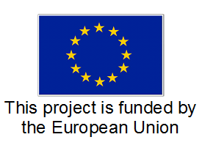 |  | 